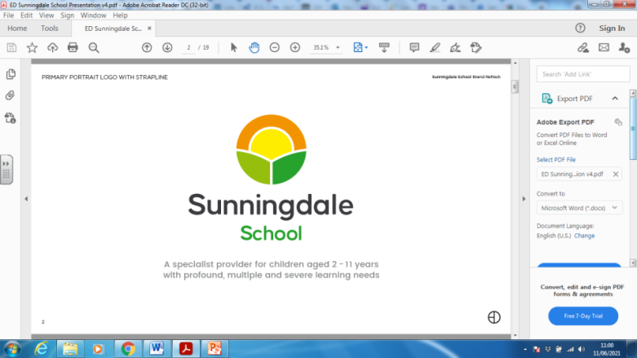
SENhub Administrative Officer
Person Specification

AREA | ESSENTIAL CRITERIA | METHOD OF ASSESSMENT*
QUALIFICATIONS  TRAINING/EXPERIENCE | Minimum of 4 GCSEs at Grade C/4 or above including  Maths and English. | AF/R
 | ICT Training or good knowledge of ICT. | AF/I/R
 | Relevant and recent administrative experience within a busy office environment. | AF/I/R
 | Knowledge of data entry procedures. | AF/I/R
 | Experience of creating or improving administrative systems. | AF/I/R
 | Experience of dealing with customers, both in person and over the telephone. | AF/I/R
SKILLS/KNOWLEDGE | Effective verbal and written communication skills, including the ability to draft correspondence, mail merge etc. | AF/I
 | Undertake ‘Reception’ duties including welcoming/signing in visitors and taking telephone calls. | AF/I
 | The ability to provide general clerical support to ensure an effective service is provided. | AF/I/R
 | The ability to maintain manual and computerised records | AF/I/R
 | Excellent organisational and interpersonal skills. | AF/I/R
 | Competent in all areas of Microsoft programmes. | AF/I/R
 | Ability to manage conflicting demands. | AF/I/R
 | Ability to work successfully within a team. | AF/I/R
OTHER REQUIREMENTS | The ability to maintain confidentiality and observe data protection guidelines. | AF/I/R
 | A willingness to learn new skills and undertake training.  . | AF/I/R
 | Able to work on own initiative and independently. | AF/I/R
 | Ability to work under pressure, manage time effectively and prioritise workload. | AF/I/R
 | Ability to be flexible and respond to need as it arises. | AF/I/R
 | Good work ethic. | AF/I
 | DESIRABLE - Ability to drive | AF/I

Method of Assessment:
AF: Application Form
I: Interview/Tasks
R: References

